Pimoroni Unicorn Hat - 8x8 RGB LED Shield for Raspberry Pi A+/B+

**DEFINITIONS**

**THREE MONOCHROME SCREEN MEMORY BUFFERS**

**LED SCREEN MEMORY MONOCHROME 2D IMAGE: The LED array as viewed by the user with badge in hand, or looking at C source code array definitions, for the case of symbols drawn on the screen.**

**Was LEDArrayMonochromeMemory [y][x] : Monochrome version of the LED Screen RAM. Easy to visualize screen memory in the form of C Syntax array. Just make sure to use the proper y, x order because of the C syntax. Upper left is 0,0 and lower right is 7,7.**

**LED SCREEN MEMORY MONOCHROME 1D PIXEL STRING: A one-dimensional array addressable 0 to 63. Upper left is 0, lower right is 63. Ordered from left to right, then top to bottom.**

**LED SCREEN MEMORY MONOCHROME 1D DATA: The LED array as viewed by the user, representing 64 bits of data as 8 rows of 8 bits (or 8 rows of bytes) with the least significant bit on the right, and the least significant byte on the bottom. In other words, the whole data value is 64 bits and bit 0 is in the lower right, and bit 63 in the upper left. This is opposite of the LED SCREEN MEMORY MONOCHROME 1D STRING.**

**DISPLAY ONE OF THE MONOCHROME SCREEN MEMORY BUFFERS USING CORRESPONDING FUNCTIONS**

**DISPLAY LED SCREEN MONOCHROME 2D IMAGE: Copies the associated screen memory into the appropriate position of the leds[63] array and sends it to the LED array.**

**DISPLAY LED SCREEN MONOCHROME 1D PIXEL STRING: Copies the associated screen memory into the appropriate position of the leds[63] array and sends it to the LED array.**

**DISPLAY LED SCREEN MONOCHROME 1D DATA: Copies the associated screen memory into the appropriate position of the leds[63] array and sends it to the LED array.**

**LED SCREEN ARRAY FASTLED: A virtual two-dimensional array addressable as in the form of y, x with a range of 0 to 7 for both values. This is part of the FastLED example library (/Examples/FastLED/XYMAtrix), and this arrangement is converted to leds[63] with awareness of the serpentine electrical arrangement of the string of LEDs using the functions XY() or YX().**

**LED ARRAY PIXEL: A single pixel**

**leds[63]: The one-dimensional array that holds color values for the FastLED library to send to the string of LEDs. The lowest LED Array data level that is easily user accessible. This arrangement follows the serpentine electrical arrangement of the LEDs on the Pimoroni Unicorn Hat.**

**VisualLED2DMatrix, User LED Matrix [x,y] : The orientation of the LED array for the user.**

**\*\*\* To convert Array to Matrix use function YX(y,x). \*\*\***

**CSyntaxCORELEDArray, C Syntax LED Array [y,x] : The orientation of the array which aligns with the C language array definition. Note the y position (row) is written first, followed by x position (column). The core matrix wires are labeled this way.**

**CSyntaxBINARYArray, Binary LED Array [y,x] : The orientation of the array which aligns with LSB in the lower right.**

**WriteOneBitToMonochromeLEDArrayMemory(uint8_t bit, bool value) : Update a single bit of LED screen Memory. Bit position is defined**

**LEDArrayMonochromeUpdate() : Read 64 bits of monochrome LED Screen memory and update the LED Array.**

**FastLED2DMatrix, FastLED (Unicorn Hat) LED Matrix [x,y] : The ordering of the LEDs defined in the FastLED library.**

**Fastled Library and Unicorn Hat LED Array Definition (daisy-chained in a serpentine)**

<http://fastled.io/> and <https://github.com/FastLED/FastLED/wiki/Basic-usage>

**leds[i]** Tested empirically with fastled by writing CHSV() values to the positions 0 to 63 into the leds[i] array.

**leds[ XY(x, y)] or leds[ YX(y, x)]** Functions to converts x,y to string position and it is aware of the decoding needed for the serpentine electrical connection.

X (horz.) listed first, Y (vert.) listed second as 0,0 and the origin is in the upper right in this image.

NUM_LEDS = 8 x 8 = 64

MatrixSerpentineLayout = true

Overloaded x values are allowed.

X +

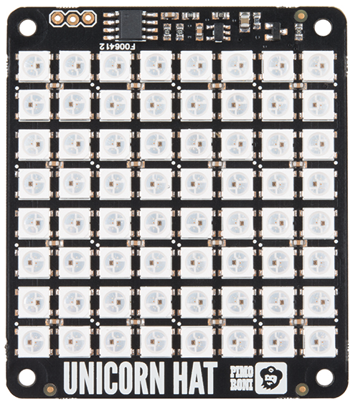

Y +

|  |  |  |  |  |  |  |  |
| --- | --- | --- | --- | --- | --- | --- | --- |
| 7  7,0  7,0 | 6  6,0  6,0 | 5  5,0  5,0 | 4  4,0  4,0 | 3  3,0  3,0 | 2  0,0  2,0 | 1  0,0  1,0 | 0  0,0  0,0 |
| 8  7,1  8,0 | 9  6,1  9,0 | 10 | 11 | 12 | 13 | 14 | 15  0,1  15,0 |
| 23  7,2  23,0 |  |  |  |  |  |  | 16  0,2  16,0 |
| 24  7,3  24,0 |  |  |  |  |  |  | 31  0,3  31,0 |
| 39 |  |  |  |  |  |  | 32 |
| 40 |  |  |  |  |  |  | 47 |
| 55 |  |  |  |  |  |  | 48 |
| 56  7,7  56,0 | 57 | 58 | 59 | 60 | 61 | 62 | 63  0,7  63,0 |

**Core 64 Badge LED Array Installation**

It is **installed in the badge** **rotated 180 degrees**. This keeps the badge width as narrow as possible and the 3 incorrect wires between the LED array and the badge as close as possible. X stays horizontal and Y stays vertical, with the origin in the lower left corner from the user view of the badge.



Y +

|  |  |  |  |  |  |  |  |
| --- | --- | --- | --- | --- | --- | --- | --- |
| 0,7 |  |  |  |  |  |  | 7,7 |
|  |  |  |  |  |  |  |  |
|  |  |  |  |  |  |  |  |
|  |  |  |  | 4,4 |  |  |  |
|  |  |  |  |  |  |  |  |
|  |  |  |  |  |  |  |  |
|  | 1,1 |  |  |  |  |  |  |
| 0,0 |  |  |  |  |  |  | 7,0 |

X +

**Core 64 Badge LED Visual Definition**

To make it easier to work with the layout of arrays in the C language syntax, the logical definition is set to align with the definition of an array in C. Visualizing letters/numbers/symbols is easier this way when writing the program.

**This requires flipping the INSTALLED array vertically**.

|  |  |  |  |  |  |  |  |
| --- | --- | --- | --- | --- | --- | --- | --- |
| 0,0 |  |  |  |  |  |  | 7,0 |
|  |  |  |  |  |  |  |  |
|  |  |  |  |  |  |  |  |
|  |  |  |  |  |  |  |  |
|  |  |  |  |  |  |  |  |
|  |  |  |  |  |  |  |  |
|  |  |  |  |  |  |  |  |
| 0,7 |  |  |  |  |  |  | 7,7 |

These are address as a C ARRAY in the order of Y (ROW), X (COL)

{0,0,1,1,0,1,1,0}, // heart

{0,1,1,1,1,1,1,1},

{0,1,1,1,1,1,1,1},

{0,1,1,1,1,1,1,1},

{0,0,1,1,1,1,1,0},

{0,0,0,1,1,1,0,0},

{0,0,0,0,1,0,0,0},

{0,0,0,0,0,0,0,0}

TECHNICAL DETAILS

Adafruit PRODUCT ID: 2288

<https://www.adafruit.com/product/2288>

<https://shop.pimoroni.com/products/unicorn-hat>

<https://www.sparkfun.com/products/14037>

3-pin header (as viewed below) left-to right: GND (closest to edge) – DIN (center) – VCC (innermost)

The larger header on the back side is on the right edge as viewed below.

Spacing of the LED array 6.4mm??? NO

UPDATED WIDTH (across solder pads) MEASURED 1.853/7=.265 in. or 47.17 mm/7= 6.74 mm

UPDATED HEIGHT MEASURED 1.812/7=.259in. or 46.03/7=6.58mm

UPDATED Split the difference to use grid with .262 inches or 6.65 mm

Use Half steps .130 inches

UPDATED Corners of grid center at x/y 7 * .130 = 0.910

Mounting Holes: L-R 1-15/16” U-D 2-9/32”, hole dia .125”

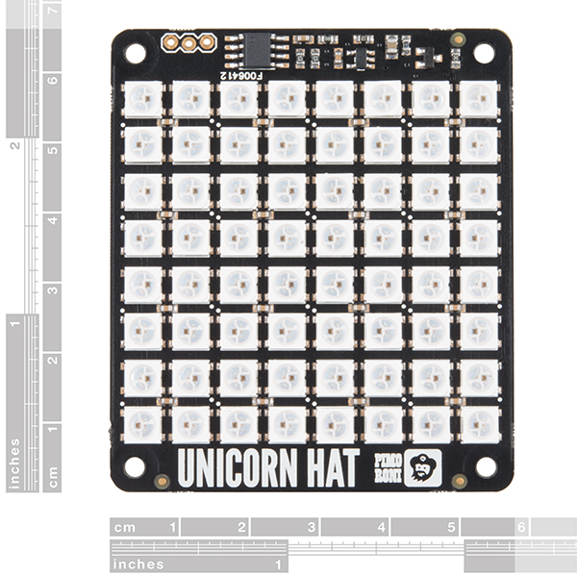holes at corners X=31/32 (.96875) Y= 1-9/64 (1.140625)

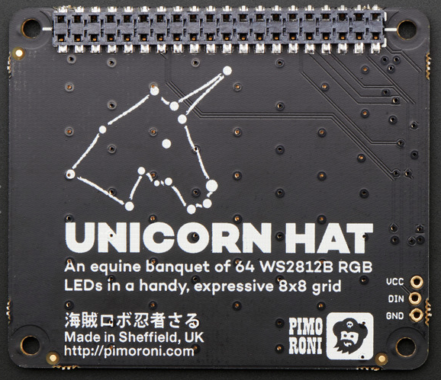

65mm x 56mm x 6.5mm / 2.6" x 2.2" x 0.26"

Weight: 20g



# DESCRIPTION

Snap the [Pimoroni](http://shop.pimoroni.com/)**Unicorn Hat** on top of a Raspberry Pi [model A+](https://www.adafruit.com/products/2266) or a [model B+](https://www.adafruit.com/products/1914) for a fun 8x8 RGB LED matrix powered directly from the Pi.

Unicorn HAT provides a wash of controllable color that is ideal for mood-lighting, 8x8 pixel art, persistence of vision effects, status indications, or just blasting colour into your surroundings.

* 64 RGB LEDs (**WS2812B**) each wtih 24-bit RGB color
* Python API (NeoPixel compatible!)
* EEPROM with Raspberry Pi HAT configuration details
* LED data driven via DMA over PWM Pin #18

Experimenting to figure out: Color order: GRB, SerpentineLayout: true

# Unicorn HAT

What's going to protect your beloved Raspberry Pi from an onslaught of rainbow-coloured fusion? That's right, it's Unicorn HAT.

Sporting a matrix of 64 (8 x 8) RGB LEDs and powered directly from the Pi, this is the most compact pocket aurora available.

Unicorn HAT provides a wash of controllable colour that is ideal for mood-lighting, 8x8 pixel art, persistence of vision effects, status indications, or just blasting colour into your surroundings.

[The MagPi](https://www.raspberrypi.org/magpi-issues/MagPi42.pdf) said that Unicorn HAT was "one of the coolest HATs around"

## **Features**

* 64 RGB LEDs (WS2812B)
* LED data driven via DMA over PWM
* [Unicorn HAT pinout](https://pinout.xyz/pinout/unicorn_hat)
* Compatible with all 40-pin header Raspberry Pi models
* [Python library](https://github.com/pimoroni/unicorn-hat)
* Comes fully assembled

## **Software**

We've put together a [Unicorn HAT Python library](https://github.com/pimoroni/unicorn-hat) to make it a breeze to use, including lots of beautiful examples of what it can do.

## **Notes**

* **Warning**: WS2812 LEDs are bright enough to cause eye pain, do not look at them directly when brightly lit. We recommend the use of a [diffuser](https://shop.pimoroni.com/products/pibow-modification-layers).
* **Photo-sensitivity warning**: flashing, strobing, and patterns of lights may cause epileptic seizures. Always take care and immediately stop using if you feel unwell (dizziness, nausea, affected vision, eye twitching, disorientation).
* **Power**: Unicorn HAT requires a >2A microUSB power supply for your Pi. We recommend [the official Raspberry Pi power supply](http://shop.pimoroni.com/products/raspberry-pi-universal-power-supply).
* **Compatibility (audio)**: as Unicorn HAT uses PWM and GPIO18, it will interfere with analogue audio playback (random colour patterns and flickering). HDMI should work just fine! :D